Program Review
Cycle for Continuous Improvement

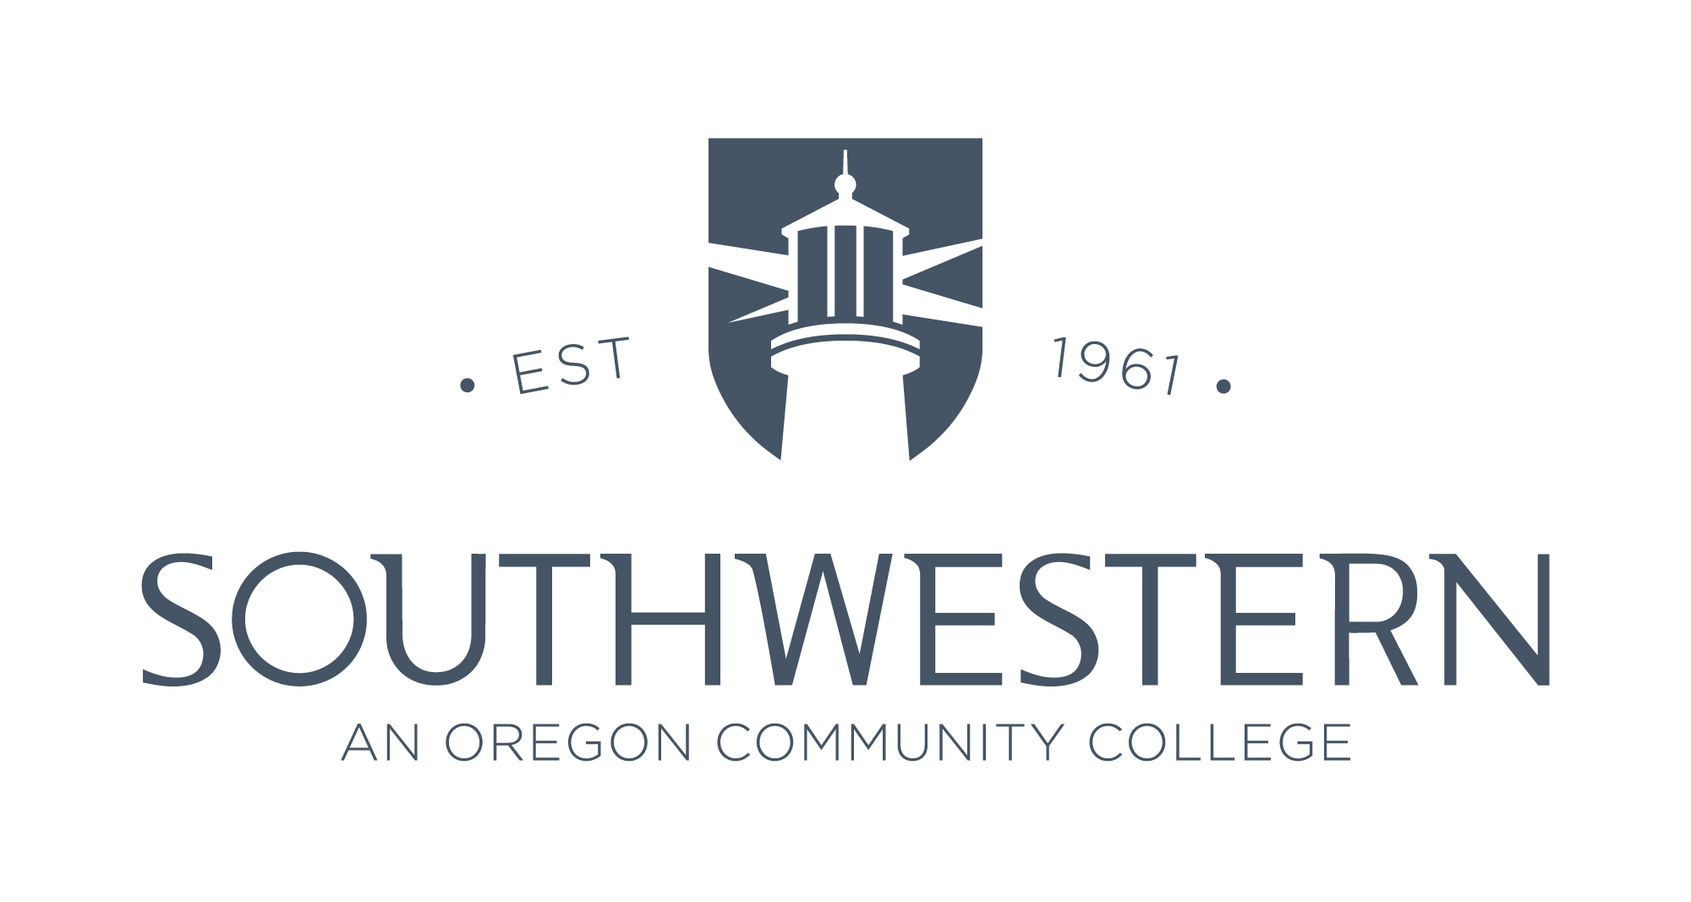

Program Name:

Program Review Team:

Date of Report:

Years Being Reviewed:

- 2018-19
- 2019-20
- 2020-21
- 2021-22

Southwestern Oregon Community College
Table of Contents

Program Review Template and Guidelines 3
Program Overview 3
Program Context 3
Program Developments 4
Data and Documentation 4
Data and Documentation: Curriculum 4
Reflection on Curriculum 4
Data and Documentation: Students 5
Reflections on Students 6
Data and Documentation: Faculty and Staff 6
Reflections on Faculty and Staff 6
Data and Documentation: Resources and Support 7
Reflections on Resources and Support 7
Data and Documentation: Community 7
Reflections on Community 7
Reflections and Analysis 8
Action Plan 8
Implementation 9

Southwestern Oregon Community College
Program Review

Program Review Template and Guidelines

The remaining parts of this document should guide the Program Review Team through each of the important sections of the Program Review report. Teams may use this document as a template. These guidelines provide suggestions, though the Team may choose to include different or additional evidence.

Program Name:

Program Review Team:

Date of Report:

Years Being Reviewed:

☐ 2018-19
☐ 2019-20
☐ 2020-21
☐ 2021-22

Program Overview
Use this section to describe the program purpose, mission, and goals. Explain how the program enables Southwestern to fulfill its mission, values, vision, and strategic priorities.

Include in this narrative:
☐ Program Purpose:
☐ Mission: Skip if no separate mission statement exists for the program.
☐ Goals: List the overall program goals that are separate from the learning outcomes.
☐ How the program fulfills the mission at Southwestern (briefly):

Program Context
Discuss the local and regional industry related to the program and the labor market conditions that may influence the program. Include other contextual information that is relevant to your program, such as social or economic conditions, or conditions specific to Southwestern. Sources such as the Census, EMSI Career Coach, Department of Labor, professional and industry associations, the Program Advisory Committee, and Oregon Revenue Forecasts, may provide crucial information to describe the program context.

In this narrative include:
☐ Recent changes and trends in working conditions for program graduates
☐ Regional demographic changes that will influence the need for program graduates in ☐ the local area, in the region or state, and beyond (as appropriate)
☐ Changes in technology, infrastructure, public policies, or working conditions that will influence the skills needed by program graduates
☐ Other relevant contextual information

Program Developments
Describe important developments since the most recent program review.

In this narrative include:
☐ Major curricular changes
☐ Changes in resources available for the program

Data and Documentation
This section of the report is subdivided into several subsections: Curriculum, Students, Faculty and Staff, Resources and Support, Community. In each subsection, provide concrete evidence documenting the current program status, as well as historical information to 2018-19, to look for trends over time. In some sections evidence to examine trends over time may be difficult to identify. Do your best with the available evidence. Use both qualitative and quantitative data. Each subsection includes space for the Team to interpret and evaluate the evidence. Contact the Assessment Specialist for assistance.

Data and Documentation: Curriculum
Include the following evidence to describe the program and its curriculum:
☐ Brief program summary
☐ Curriculum map documenting the link between program learning outcomes and courses
☐ Program learning outcomes
☐ Brief description of courses, along with documentation and reflection discussing changes in the courses, and alignment with preceding and following courses
☐ Summary of course format and/or location offerings (e.g., Curry, online)
☐ Note service-learning and other important course attributes
☐ Program-specific articulation and transfer agreements
☐ External curricular requirements, such as licenses and accreditation

Reflection on Curriculum
How well does the curriculum reflect the local community needs? How well does it align with industry and professional standards? How has the community or industry changed since the curriculum was last modified?

☐ Summarize key reflections about the curriculum in one paragraph

Data and Documentation: Students
The Assessment Specialist will help the Program Review Team obtain student enrollment and completion data. Include the following evidence to describe students’ participation and achievement in the program:
- Enrollment – from IE
- Course completion – from IE
- Program completion – from IE
- Transfer – from IE
- Employment – may use qualitative data from Advisory Committee, alumni, or other evidence
- Learning outcomes – from Faculty Program Assessment Plans and Reports
- Satisfaction – course evaluations, other evidence

Where available, and especially for course and program completion, data should be disaggregated by important demographic indicators. Some populations of students who attend Southwestern in small numbers may need to be discussed narratively to avoid identifying specific students. Demographic indicators should include:
- First-time/first-year students
- Sex
- Age
- Race/Ethnicity
- Full-time/part-time enrollment
- Financial aid
- Location

Student Enrollment, Transfer, Completion
Include:
☐ Demographic data table(s) or summarize narratively, as appropriate to the student pool. Note that tables with cell values < 10 must be suppressed to protect student identity.
☐ Identify one to two demographic indicators that suggest a program success, and
☐ Identify one to two demographic indicators that suggest some students may be struggling or not as well served as other students.
☐ Present the results in a graph to provide a visual snapshot of these findings.

Contact the Assessment Specialist for assistance.

Student Learning:
List each of the program learning outcomes. Use the Faculty Program Assessment Plans, Faculty Program Assessment Reports, and other sources of information to identify which of the learning outcomes were assessed during the academic year, how they were assessed, and the results of the assessments, including any changes to the course, teaching-and-learning, or to the program. Among the learning outcomes that were assessed, did you learn what you need to know to make decisions? Which outcomes could be either measured more effectively by faculty, or achieved more proficiently by students?

Program Learning Outcomes | Assessment Processes and Tools | Assessment Results and Subsequent Changes

Reflections on Students
Which populations of students seem to be served well by the program? Which populations of students might be lagging in enrollment, completion, and satisfaction relative to the surrounding community or other programs? Why might that be? What additional information or data would help you to understand and explain the story of the program’s students?

☐ Summarize key reflections about students in one paragraph

Data and Documentation: Faculty and Staff
Include the following evidence to describe the faculty and staff that are a part of the program, including their contributions to Southwestern and to the profession, as well as the resources and support available to them.

Include:
☐ Full-time and part-time faculty (numbers, specializations)
☐ Professional Service and scholarly activities such as special projects, grants, professional associations, publications, presentations
☐ Faculty development such as departmental activities, conferences, training, and coursework in which faculty have participated
☐ Other important opportunities and resources for faculty

Reflections on Faculty and Staff
What are the strengths the faculty and staff bring to the program? To what extent do faculty take advantage of resources and opportunities? Why might faculty take advantage of some opportunities, but not others? To what extent do the faculty reflect the students? The surrounding community? What might strengthen the faculty’s capacity to serve Southwestern’s constituency? What additional information or data would help you to understand and explain the story of the program’s faculty?

☐ Summarize key reflections about faculty in one paragraph

Data and Documentation: Resources and Support
Include the following evidence to describe the resources and support for the program, including financial, physical, infrastructure, and college resources that are available to the program.
☐ Financial resources (summary budget)
☐ Program-specific scholarships or aid
☐ Instructional and learning resources
☐ Facilities, equipment, technology, and other infrastructure
☐ Marketing and recruiting – departmental resources, and from Southwestern recruitment and admissions
☐ Advising – departmental resources, and from Southwestern’s Advising Center

Reflections on Resources and Support
To what extent do the financial, physical, and other resources support the curriculum? The students? The faculty? What resources might need to be reinforced to strengthen enrollment, program delivery, and completion? Why might some available resources support the program better than others? What mission-critical resources might be missing altogether? What additional information or data would help you to understand and explain the program’s resources?

☐ Summarize key reflections about program resources in one paragraph

Data and Documentation: Community
For each of the following community categories identify the participants, describe specific benefits the program has received through the relationship, and changes that have been made to the program as a result of the relationship:
☐ Advisory Committee (individuals and organization, active participants)
☐ Community and industry partnerships
☐ PK-12 school partnerships
☐ Other types of community-based relationships

Reflections on Community
How well is the program grounded in the community? To what extent are the partnerships a benefit to the program? Which partnerships could be strengthened or might be missing altogether? What could they provide for the program? What additional information or data would help you to understand the story of the program’s community?

☐ Summarize key reflections about the community in one paragraph

Reflections and Analysis
Summarize and reflect on the results of the Team’s findings.

Use this narrative to answer each of the following questions:
☐ What is the overall story of the program as told by the evidence?
☐ What are the internal strengths?
☐ What are the internal weaknesses?
☐ What are the external opportunities?
☐ What are the external challenges?
☐ How can the internal weakness be turned into strengths?
☐ How can the external challenges be leveraged into opportunities?
☐ Which parts of Southwestern’s constituency could be better served by the program?
☐ How well does the program fulfill the mission, vision, values, and strategic priorities of Southwestern Oregon Community College?

Action Plan
Identify at least two, but no more than four, strategic program activities to implement over the next four years, based on the results of the Team’s analysis and reflections. Use the planning worksheet to describe the intended outcomes, timeline, resources, participants, and evaluation required for each of the major activities. The Team should present the findings and discuss the action plan with the Program Advisory Committee, or other external partner suitable to provide insights, such as an ad hoc committee or colleague(s) from an articulated or transfer program. After synthesizing feedback from the Advisory Committee and finalizing the action plan, submit the Program Review report to the Vice President of Instruction and to the Assessment Specialist. The artifacts described in the action plan should be the Team’s guide to evidence that will be needed in the next program review cycle.

Activity | Timeline and Champion | Required Resources | Collaborators | Status Update
Briefly describe the activity, intended outcomes and evidence of success | Owner/Lead | Projected costs, equipment, software, staff, and impact on other departments |  | Record progress
 | Start Date
 | End Date
Activity 1:
SWOCC Strategic Priority | Student Success Enrollment Equity Capital Technology
1.1
1.2
1.3
Activity 2:
SWOCC Strategic Priority | Student Success Enrollment Equity Capital Technology
2.1
2.2
2.3
Activity 3:
SWOCC Strategic Priority | Student Success Enrollment Equity Capital Technology
3.1
3.2
3.3

Implementation

Each year, the Program Review Team should meet to review the action plan and to establish goals and a workplan with detailed tasks and a timeline for the upcoming year. Program lead(s) should identify the costs that will be incurred through implementation of the action plan and submit the request to the program Dean or Director through the annual budgeting worksheets. All budget requests must be tied to Southwestern’s strategic priorities. The Program Review Team may evolve in accordance with the needs of the action plan for a given year. Each year, prior to the end of fall term, program lead(s) should provide a half- to one-page summary of progress. The annual summary should include an update on the action plan, as well as changes in student enrollment, program costs and major changes in the industry. Summary updates can be based on anecdotal observations. Changes in enrollment related to the action plan, or that suggest some students may be experiencing new challenges, are especially important to include. Submit the annual update summary to the Vice President of Instruction and to the Assessment Specialist.

Contact:
Vice President of Instruction
(541) 888-7417
Ali.Mageehon@socc.edu

Assessment Specialist
(541) 888-7055
ProgramReview@socc.edu

Southwestern Oregon Community College does not discriminate on the basis of race, color, gender, sexual orientation, marital status, religion, national origin, age, disability status, gender identity, or protected veterans in employment, education, or activities as set forth in compliance with federal and state statutes and regulations.

