|  |  |
| --- | --- |
| **SWOCC Field Trip/Excursion Emergency Contacts** | |
| **Form Purpose**  This form is used to provide quick access to emergency contacts for Southwestern Oregon Community College. It should be utilized in case of any emergency situations while on a field trip/excursion to ensure the safety and well-being of all students and staff. | |
|  | |
| **Name and Role** | **Phone and Email** |
|  | |
| **Campus Safety** | (541) 297-4200 (Available 24 Hours)  [swoccsecurity@socc.edu](mailto:swoccsecurity@socc.edu) |
|  | |
| **Kyle Croy**  Director of Facilities Services | (541) 888-7229 or (541) 888-7250 (8am – 5pm)  (541) 441-8051 – Cell  [kcroy@socc.edu](mailto:kcroy@socc.edu) |
|  | |
| **Rachele Lyon**  Vice President of Administrative Services | (541) 888-7402 or (541) 888-7206 (8am – 5pm)  (541) 297-0123 – Cell  [Rachele.lyon@socc.edu](mailto:Rachele.lyon@socc.edu) |
|  | |
| **John Atkinson**  Director of Conduct and Community Standards | (541) 888-7098 (8am – 5pm)  [John.atkinson@socc.edu](mailto:John.atkinson@socc.edu) |
|  | |
| **Ali Mageehon**  Vice President of Instruction and Student Services | (541) 888-7417 or (541) 888-7214 (8am – 5pm)  [Ali.mageehon@socc.edu](mailto:Ali.mageehon@socc.edu) or [jhansford@socc.edu](mailto:jhansford@socc.edu) |
|  | |
| **Adam Whitlatch**  Dean of Athletics, Health and Physical Education, Recreation | (541) 888-7228 (8am – 5pm)  [awhitlatch@socc.edu](mailto:awhitlatch@socc.edu) |

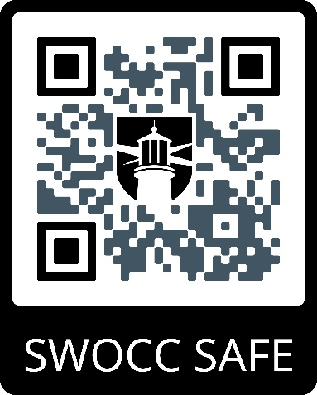

**Maxient Incident Reporting**