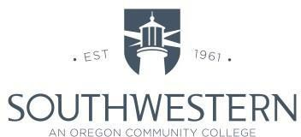

Safety Committee Meeting Minutes/Agenda
Chairperson: Rob Aton
Notetaker: Rob Aton
Attendees: Joe Belter, Mike Herbert, Shawn Warren, Mike Wolf, Chelsea Clemens, Paul Vermeer, Rob Aton, Mary Koski
Date: October 19, 2022
Curry County: 541-469-5017

Note: Items that have strike out mean that they have been completed. They will be removed from the minutes at the next meeting. Information may include current month’s activities up to the date of the subsequent meeting.
OLD BUSINESS
- Update on Coaledo clean up.
NEW BUSINESS/AGENDA

AGENDA
- Hazard Inspections

HAZARD INSPECTIONS
- Umpqua – Submitted by Amy Burgess on 10/14/22 – No recommendations were submitted
- Stensland – Submitted by Shawn Warren on 10/19/22 – No recommendations were submitted

ACCIDENTS AND NEAR MISSES
- There were no injuries or near misses in September 2022

Next safety meeting is scheduled for November 16, 2022 at 3:00 pm via Zoom

Southwestern Oregon Community College is an equal opportunity employer and educator.

