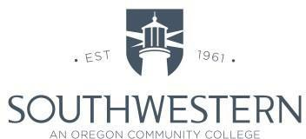

Safety Committee Meeting Minutes/Agenda
Chairperson: Rob Aton
Notetaker: Rob Aton
Attendees: Joe Belter, Mike Herbert, Shawn Warren, Mike Wolf, Chelsea Clemens, Paul Vermeer, Rob Aton, Mary Koski
Date: September 21, 2022
Curry County: 541-469-5017

Note: Items that have strike out mean that they have been completed. They will be removed from the minutes at the next meeting. Information may include current month’s activities up to the date of the subsequent meeting.
OLD BUSINESS
- No previous minutes
NEW BUSINESS/AGENDA

AGENDA
- No previous minutes
- Hazard Inspections
- Chemical Waste/Hygiene – Since the move from Coaledo to Umpqua, there was a large number of chemicals left in Coaledo that need to be disposed of. Amy Burgess has been working on this and Rob is getting quotes for the final cleanup.

HAZARD INSPECTIONS
- Tioga – Submitted by Mary Koski on 8/17/22 – Followed up to fix concerns.
- OCCI – Submitted by Shawn Warren on 9/12/22 – No recommendations were submitted
- Newmark – Submitted by Rob Aton on 9/21/22 – Couple of maintenance issues.

ACCIDENTS AND NEAR MISSES
- There were no injuries or near misses in August 2022

Next safety meeting is scheduled for October 19, 2022 at 3:00 pm via Zoom

Southwestern Oregon Community College is an equal opportunity employer and educator.

